SUPPORT
ACHIEVE
INNOVATE
RESEARCH
ENJOY
PARTICIPATE

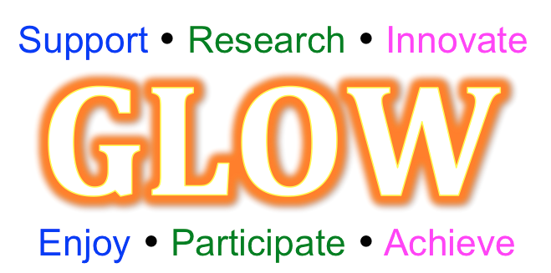

REFLECTIVE LOG
Reflection is important for effective professional development,
and also contributes to effective evaluation.

Name
School

The reflective log aims to support participant teachers record key points they feel are beneficial to their knowledge, pedagogy and classroom practice as they progress through the workgroup and gap tasks of the work group. This then supports the completion of the final workgroup evaluation to be handed in at the final workshop. The journal itself is a personal document to the participant and not for wider sharing.
This Work Group aims to develop:
Professional Learning
- Mastery Advocates will have a deep understanding of the principles and practices associated with Teaching for Mastery
- They will learn about the 5 big ideas, how these are being implemented in primary schools and gain an appreciation of how KS2 pupils’ mathematical knowledge, skills and understanding are developing
- They will consider the implications of this for KS3 practice and will learn about teaching for mastery practices that have already been explored and developed so far at KS3 as well as learning and developing skills through their own experimentation with the 5 big ideas

Teaching and/or leadership practice
- Mastery Advocates will explore ways of incorporating the 5 big ideas into their own practice
- Mastery Advocates will lead the teachers in their department in developing these approaches in their practice.

Whole School /departmental policies and approaches
- Mastery Advocates will work to develop and embed teaching for mastery approaches across their own departments
- In the initial stages this will involve exploring approaches in lessons and supporting the development of colleagues’ practice, but this will grow to include developing schemes of work and other departmental systems and structures to allow for teaching for mastery approaches to be embedded.

Pupil achievement, attitudes, participation or experience
- Pupils will develop a deep, secure and connected understanding of the mathematics they are learning.
- Pupils achieve both conceptual understanding and procedural fluency at each stage of their learning and see mathematics as a subject which is interesting, stimulating and enjoyable.
- There are high levels of achievement in mathematics.
- Pupils enjoy mathematics lessons and have a positive attitude to learning the subject.

The structure of the work group:
TRG 1
Date
TRG 3
Date
TRG 2
Date
TRG 4
Date

Gap Task 2
Gap Task 1
Gap Task 3

Reflective Log completion instructions
The Reflective Log provides two templates:

- Workshop reflection template

This is completed during the workshop and allows participants to note any key observations and action points during the workshop.

i) The key observation section provides an opportunity to reflect on:
a) Outcomes for myself
- What are you learning while participating in this Work Group/Programme?
- How is your practice developing while participating in this Work Group/Programme?

b) Outcomes for others
- How is the Work Group leading to change for your colleagues or your school/department’s policies and approaches?
- How is the Work Group leading to outcomes for your pupils?

c) Any other reflections
ii) The key actions section provides an opportunity to consider ‘What will I do differently back in school and/or in my classroom practice?’
2) Gap task reflection template
This is in two parts:
- Part 1 is completed in school and crucially records the key points to bring along to inform the gap task feedback session at the next workshop.
- Part 2 is completed during the gap task feedback session in the next workshop and allows teachers to make further notes resulting from this important group discussion.

When considering your Gap tasks and development:
- How will you begin to work on the chosen focus? What might be your first step?
- Where will you go next with it and how might it develop over the weeks ahead?
- When during the week might you incorporate your focus element?
- How will you show this on your usual maths plans?
- What evidence are you planning to gather during and after each session
- How will you ensure your work is effective with the children in your class?
- How will you evaluate at each point (after each session / week)?
- How will you note any changes / adaptations you make along the way?
- How will you assess whether the children have made any progress using your chosen focus?
- How will you evaluate how effective your practice has been and how much you have developed during the project
Workshop 1 Reflection
Workshop focus:
Key observations | Key actions

Gap task 1 Reflection
Part 1: Key points

Part 2: Key points from workshop feedback discussion

Workshop 2 Reflection
Workshop focus:
Key observations | Key actions

Gap task 2 Reflection
Part 1: Key points

Part 2: Key points from workshop feedback discussion

Workshop 3 Reflection
Workshop focus:
Key observations | Key actions

Gap task 3 Reflection
Part 1: Key points

Part 2: Key points from workshop feedback discussion

Workshop 4 Reflection
Workshop focus:
Key observations | Key actions

Gap task 4 Reflection
Part 1: Key points

Part 2: Key points from workshop feedback discussion

