SUPPORT
ACHIEVE
INNOVATE
RESEARCH
ENJOY
PARTICIPATE

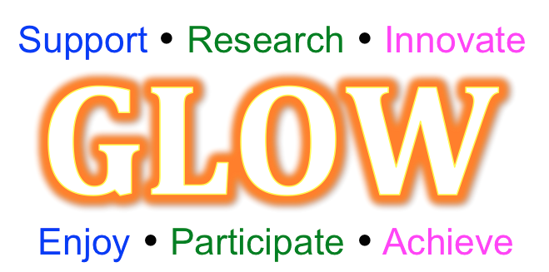

REFLECTIVE LOG
Reflection is important for effective professional development,
and also contributes to effective evaluation.

Name:
School:

The reflective log aims to support participant teachers record key points they feel are beneficial to their knowledge, pedagogy and classroom practice as they progress through the workgroup and gap tasks of the work group. This then supports the completion of the final workgroup evaluation to be handed in at the final workshop. The journal itself is a personal document to the participant and not for wider sharing.
This Work Group aims to develop:
Professional Learning
TBC by WGL
Practice development
TBC by WGL
School/department policy/approaches
TBC by WGL
Pupil outcomes
TBC by WGL

The structure of the work group:

Workshop 1
Date
Workshop 2
Date
Workshop 3
Date
Workshop 4
Date

Gap Task 3
Gap Task 1
Gap Task 2

Reflective Log completion instructions:

The Reflective Log provides two templates:

- Workshop reflection template

This is completed during the workshop and allows participants to note any key observations and action points during the workshop.

i) The key observation section provides an opportunity to reflect on:
a) Outcomes for myself
- What are you learning while participating in this Work Group/Programme?
- How is your practice developing while participating in this Work Group/Programme?

b) Outcomes for others
- How is the Work Group leading to change for your colleagues or your school/department’s policies and approaches?
- How is the Work Group leading to outcomes for your pupils?

c) Any other reflections
ii) The key actions section provides an opportunity to consider ‘What will I do differently back in school and/or in my classroom practice?’

2) Gap task reflection template
This is in two parts:
- Part 1 is completed in school and crucially records the key points to bring along to inform the gap task feedback session at the next workshop.
- Part 2 is completed during the gap task feedback session in the next workshop and allows teachers to make further notes resulting from this important group discussion.

Here are some suggested ideas to gather evidence for your Gap tasks:
+ Complete the journal ready for your next meeting (essential)
+ Samples of lesson designs
+ Examples of pupils work from lessons
+ Staff and pupil interviews, discussions or questionnaires
+ Any quantitative progress data available from school’s usual methods

Workshop 1 Reflection
Workshop focus:
Key observations | Key actions

Gap task 1 Reflection
Part 1: Key points

Part 2: Key points from workshop feedback discussion

Workshop 2 Reflection
Workshop focus:
Key observations | Key actions

Gap task 2 Reflection
Part 1: Key points

Part 2: Key points from workshop feedback discussion

Workshop 3 Reflection
Workshop focus:
Key observations | Key actions

Gap task 3 Reflection
Part 1: Key points

Part 2: Key points from workshop feedback discussion

Workshop 4 Reflection
Workshop focus:
Key observations | Key actions

Gap task 4 Reflection
Part 1: Key points

Part 2: Key points from workshop feedback discussion

